1. **C Programming History :**

The origin of C is closely tied to the development of the [Unix](https://en.wikipedia.org/wiki/Unix" \o "Unix) operating system, originally implemented in [assembly language](https://en.wikipedia.org/wiki/Assembly_language" \o "Assembly language) on a [PDP-7](https://en.wikipedia.org/wiki/PDP-7" \o "PDP-7) by Dennis Ritchie and Ken Thompson, incorporating several ideas from colleagues.

Eventually, they decided to port the operating system to a [PDP-11](https://en.wikipedia.org/wiki/PDP-11" \o "PDP-11). The original PDP-11 version of Unix was also developed in assembly language.

Thompson desired a programming language to make utilities for the new platform. At first, he tried to make a [Fortran](https://en.wikipedia.org/wiki/Fortran" \o "Fortran) compiler, but soon gave up the idea.

Instead, he created a cut-down version of the recently developed [BCPL](https://en.wikipedia.org/wiki/BCPL" \o "BCPL) [systems programming language](https://en.wikipedia.org/wiki/Systems_programming_language" \o "Systems programming language).

The official description of BCPL was not available at the time and Thompson modified the syntax to be less wordy, producing the similar but somewhat simpler.

However, few utilities were ultimately written in B because it was too slow, and B could not take advantage of PDP-11 features such as [byte](https://en.wikipedia.org/wiki/Byte" \o "Byte) addressability.

In 1972, Ritchie started to improve B, which resulted in creating a new language C. The C compiler and some utilities made with it were included in [Version 2 Unix](https://en.wikipedia.org/wiki/Version_2_Unix" \o "Version 2 Unix).

**2) Write a c program to find as follows :**

**a) a=30 ,b =20 find a/b, where a and b are float**

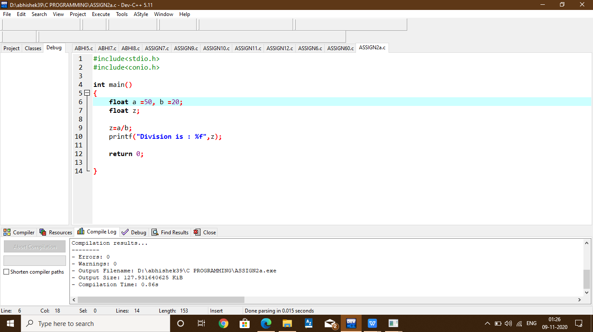

**b) Program to find the area of circle and rectangle.**

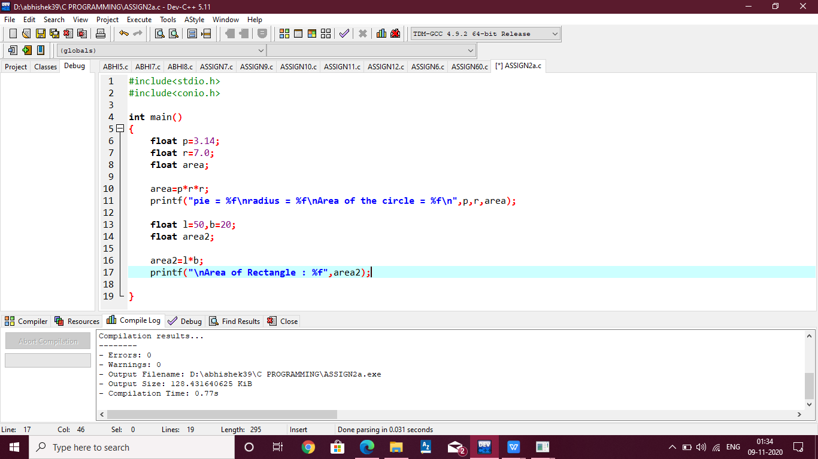

**c) Program to print your name with your age.**

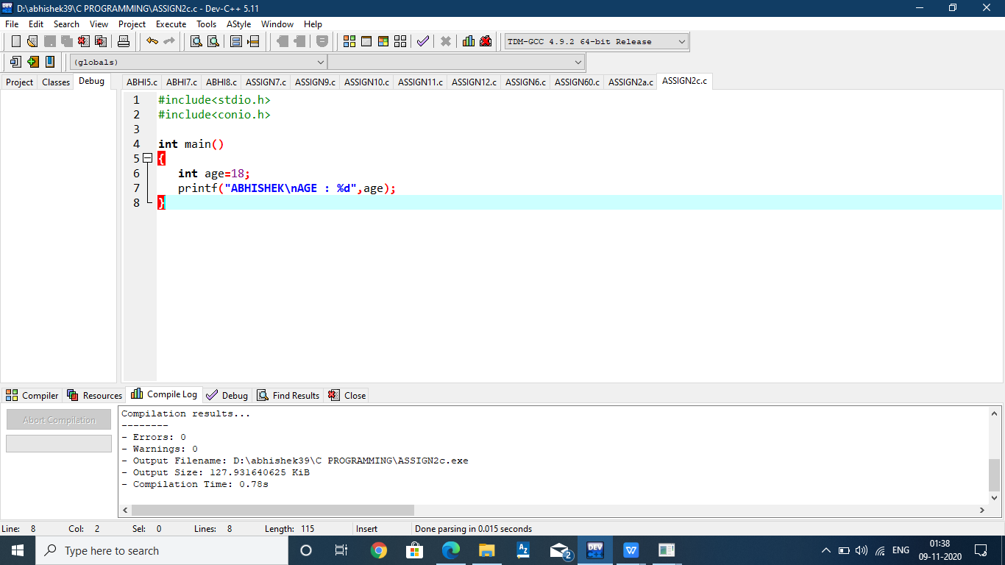

**3) Write a program to calculate the following :**

**a= 3.5 ; b=2.5 1) a2+b2+2ab 2) a2 /b2**

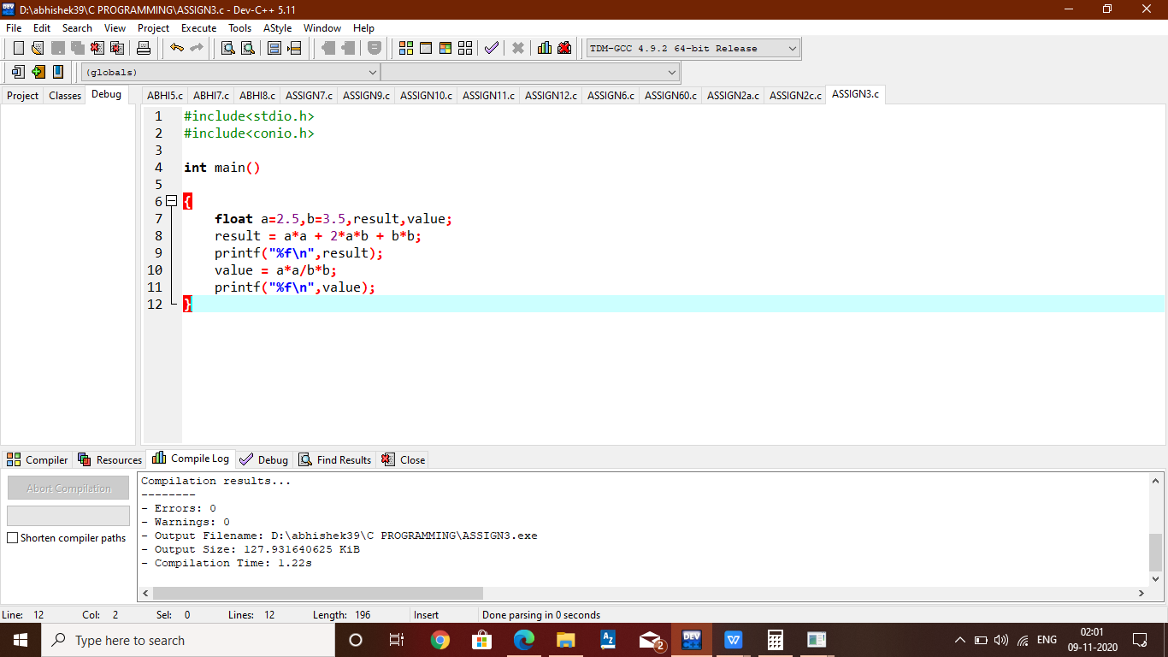

**4)Write a program to define an integer ,character ,float and double values and print all values along with its size.**

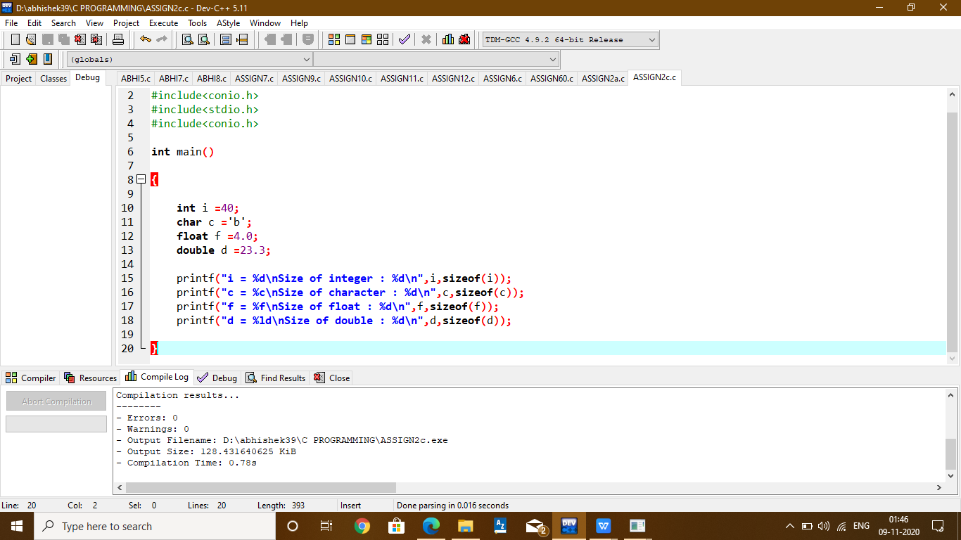

**5) Create a program to take 2 values from user and print addition, multiplication ,subtraction and division.**

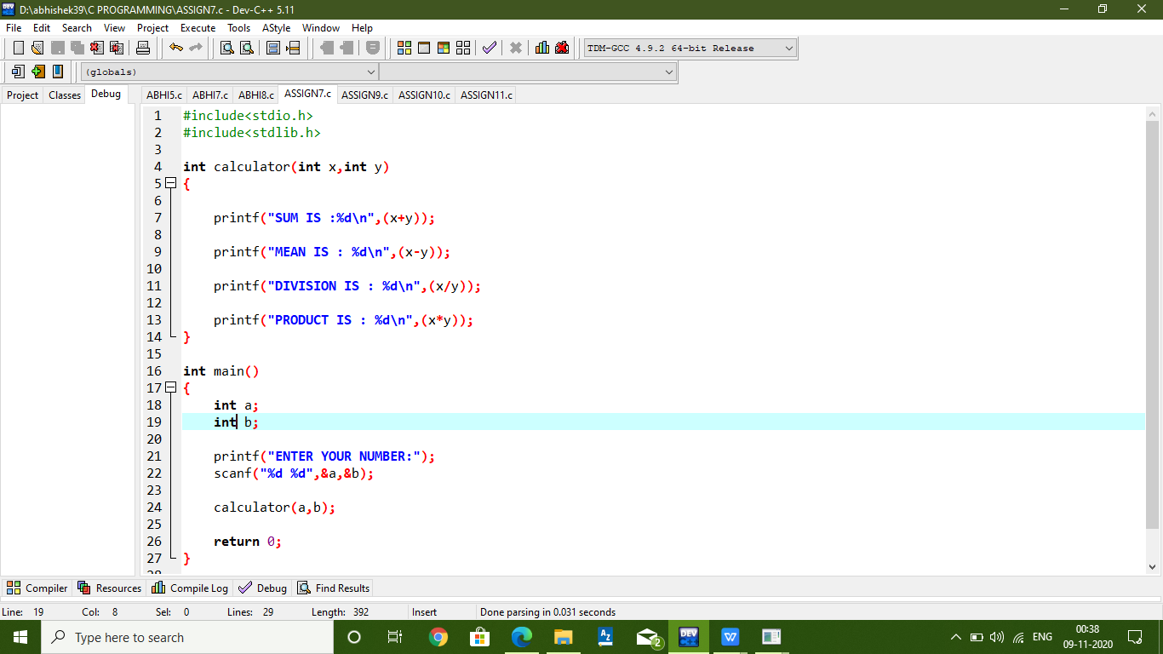

1. **Take two numbers from user and compare values and print results as false or true.**

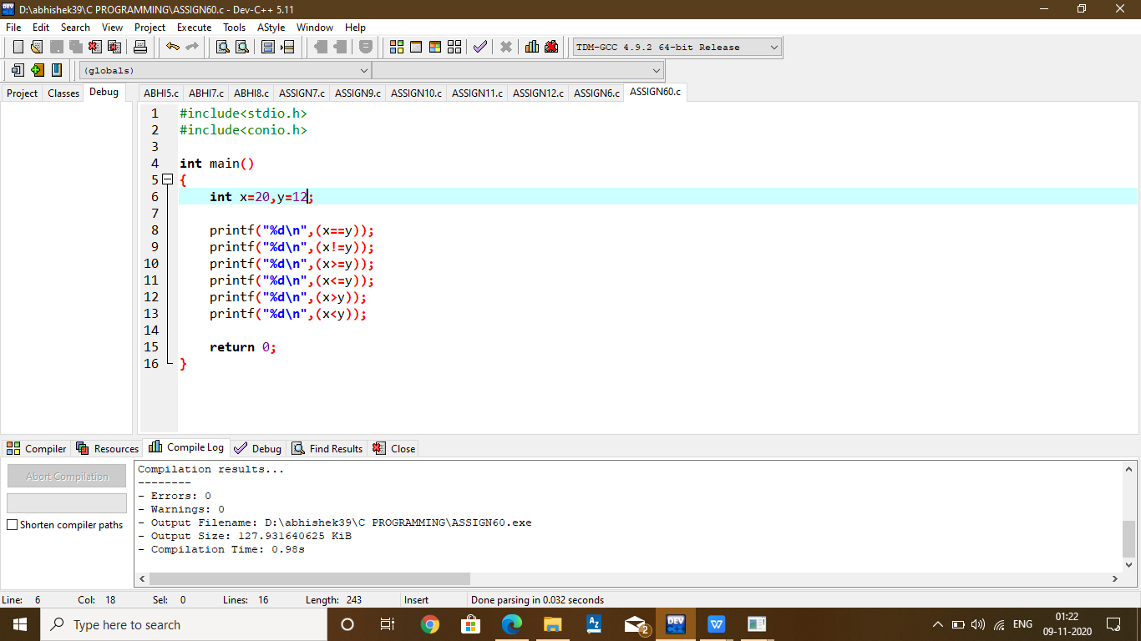

1. **Create two variables , one is integer and other is double and do the operations like multiplication and subtraction on these variable.**

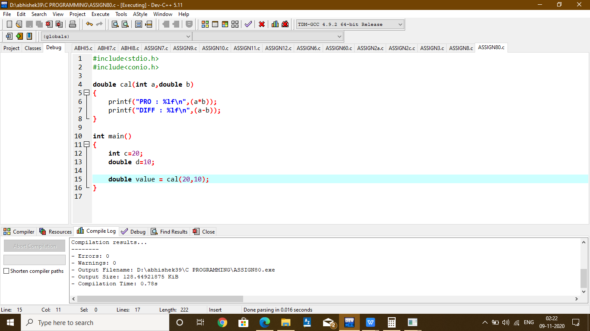

**8)Write a program to define a function Calculator() which accepts two integer values and print sum,subtraction,division and multiplication.**

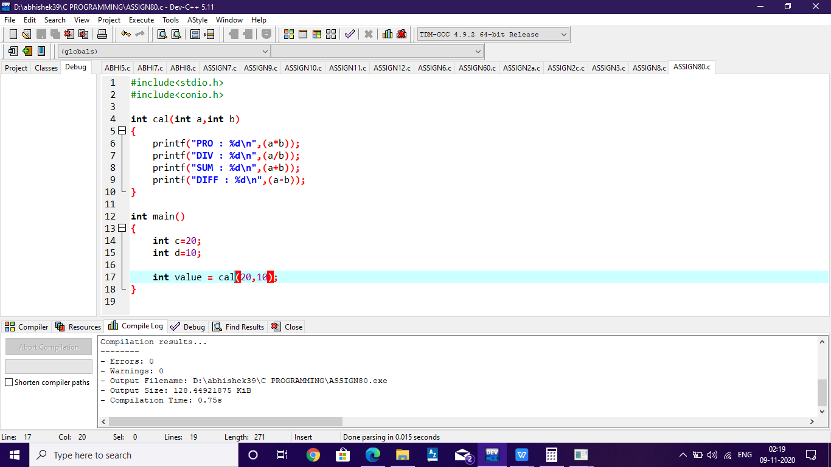

**9)Write a program to define a function which takes a number from user and print the number.**

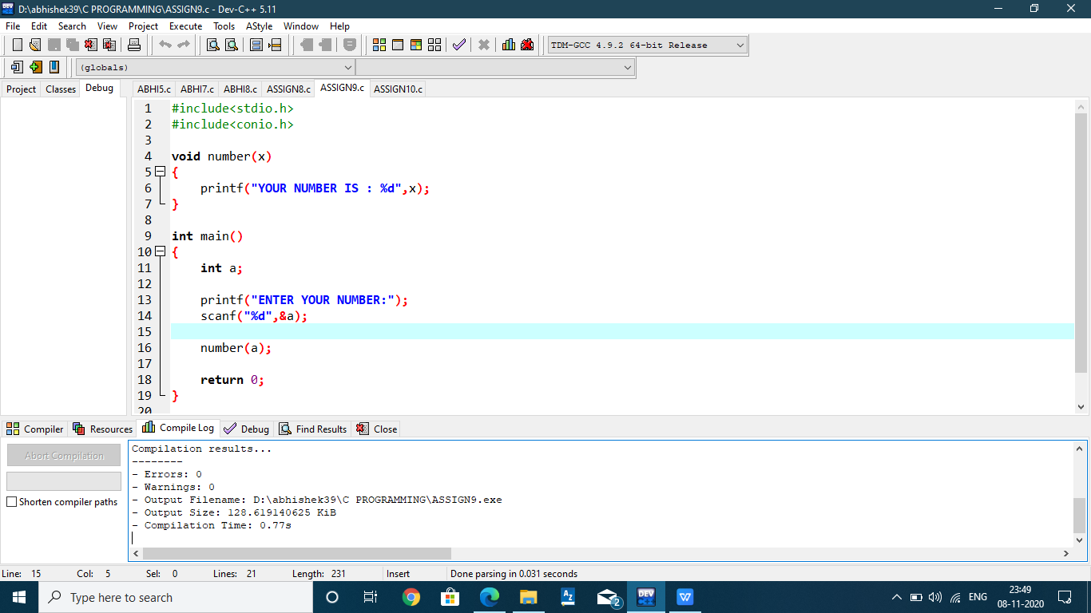

**10)Write a program to take a number from user and pass this number to the function named as Square() which returns the square of the number and print square value in main.**

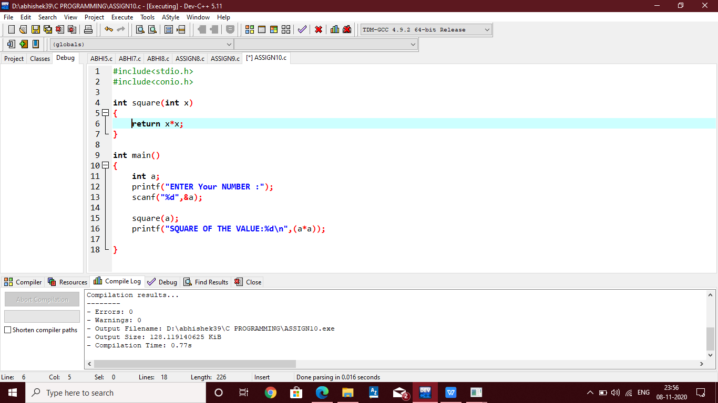

**11)Write a function which takes a character in small case and returns the same character in capital case.**

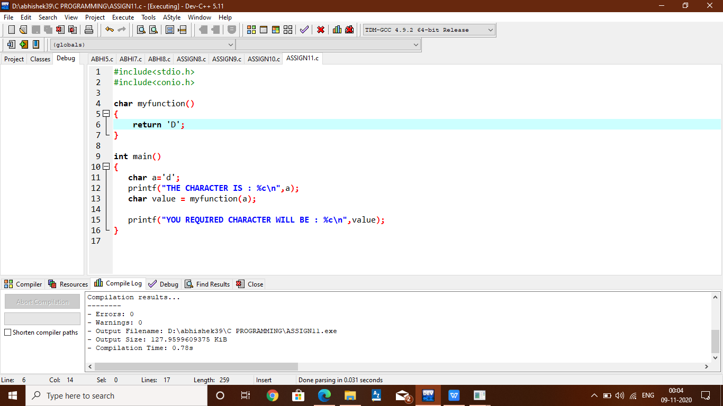

**12)Write a program to display the result acoording to following using if only : marks < 40 : Fail; 40 <= marks <65 : Second Division ; 65 <= marks < 75 : First Division; 75 <= marks : Distinction**

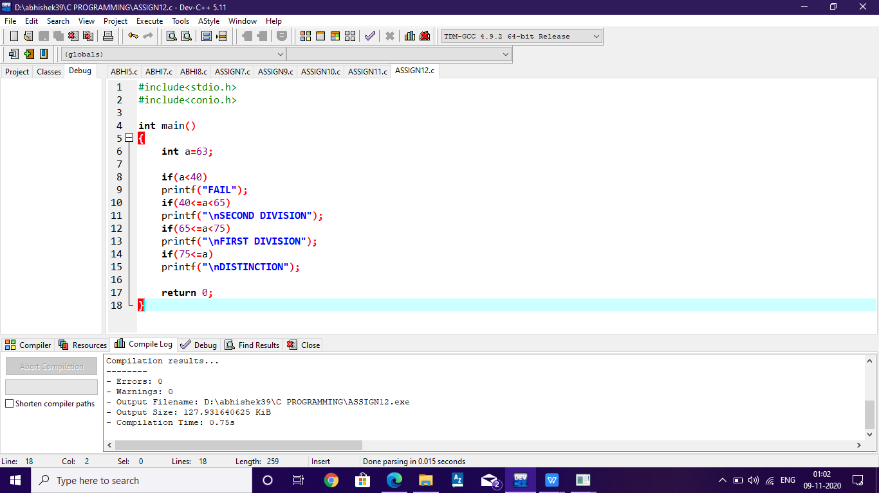

1. **Write a program to find the largest of two numbers given by user.**

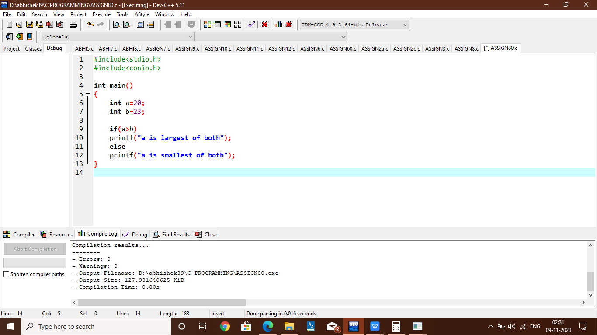

**14) Write a program using switch....case , create a function which takes two values as parameters**

**+ ======> Do Addition of two nos.**

**- ======> Subtraction**

**/ ======> Division**

**\* ======> Multiplication**

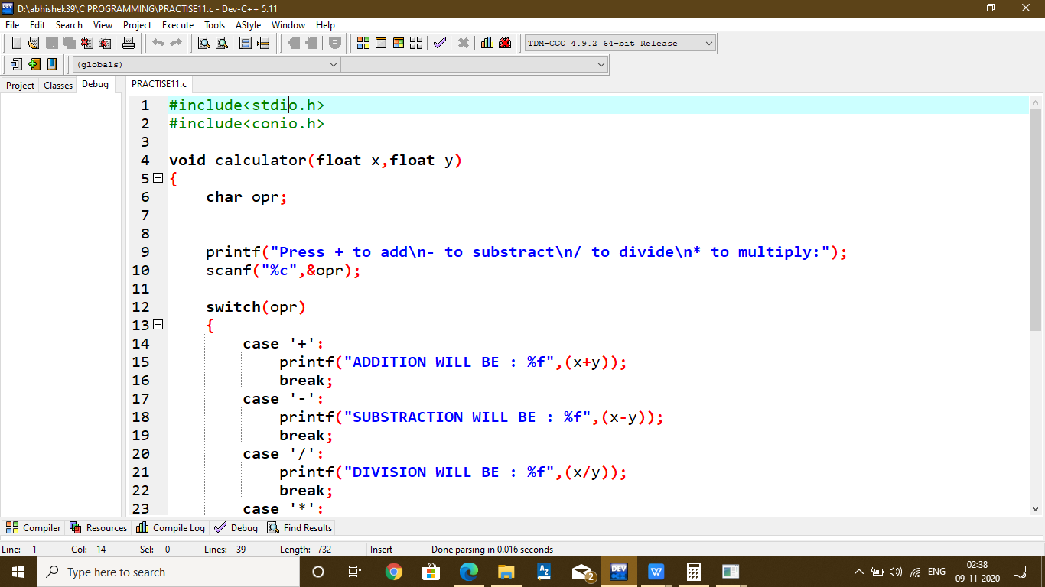

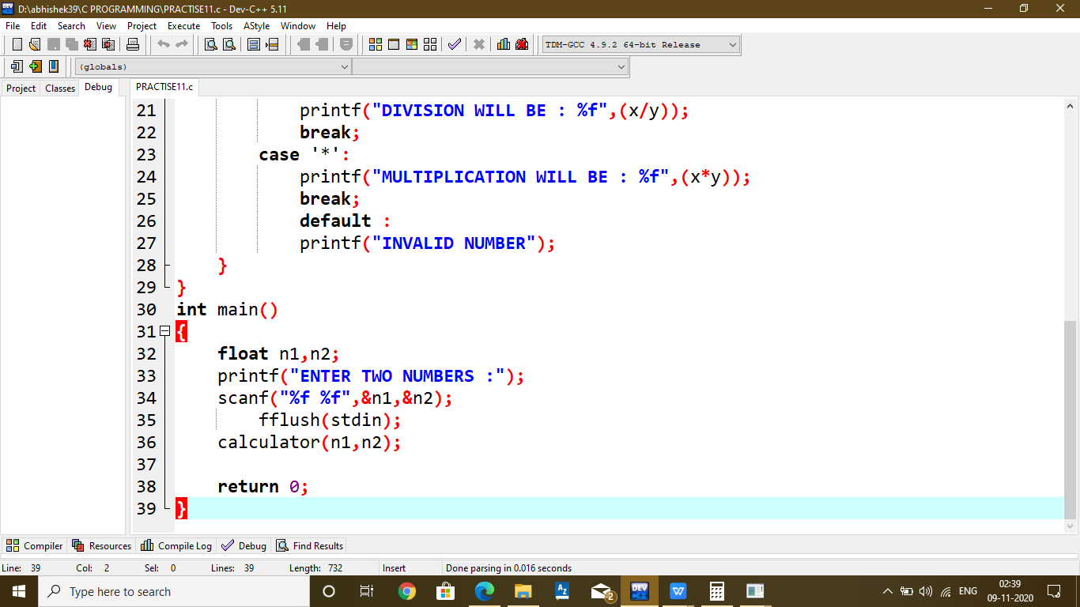

**15) Write a program to do the following using switch...case**

**Read percentage of a student inside a function and check if the percentage lies in the following range and print the Grade accodingle :**

**80<per<=100 : A+ 60<per<=80 : A per<60 : Fail**

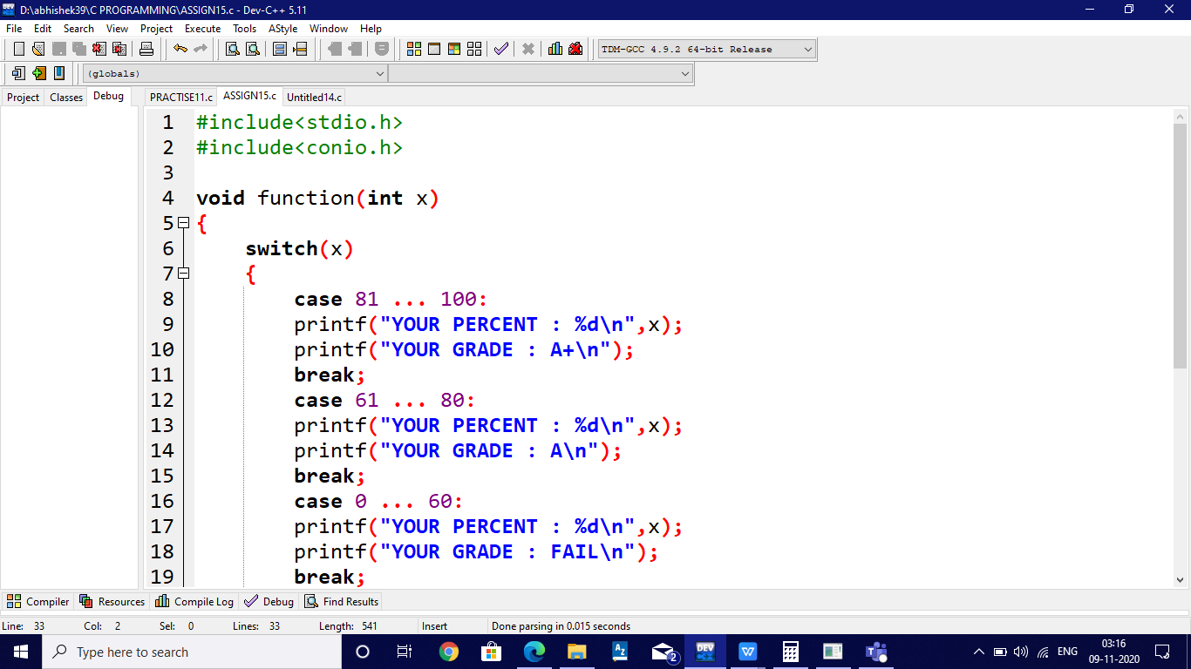

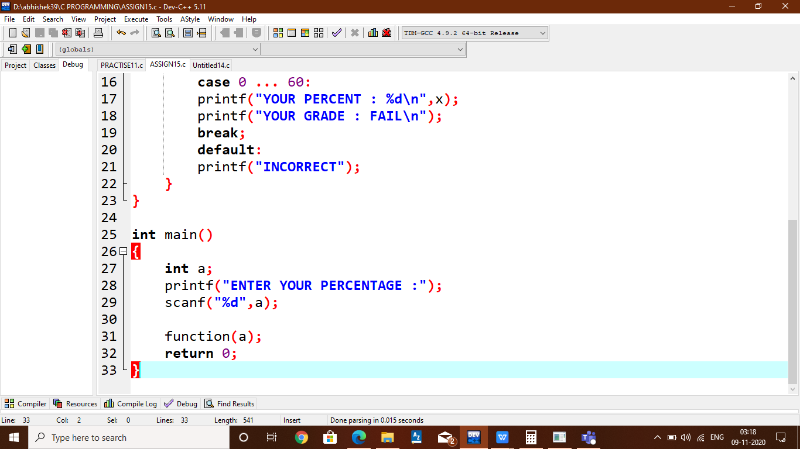

**16) Display the following Pattern :**

**\***

**\*\***

**\*\*\***

**\*\*\*\***

**\*\*\*\*\***

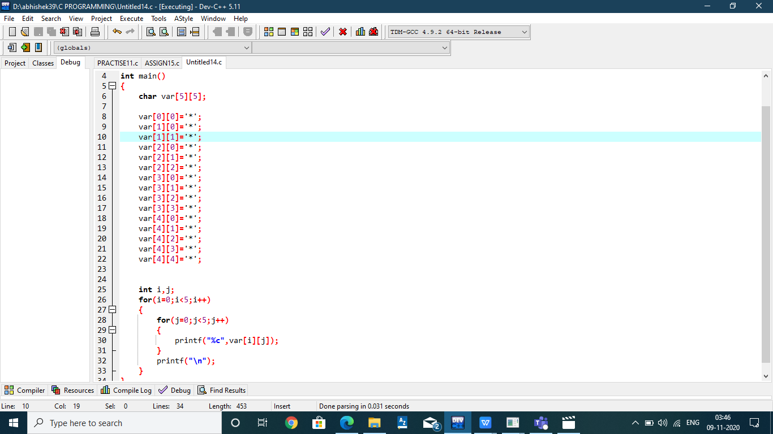]

**17)Print the table of the entered number.**

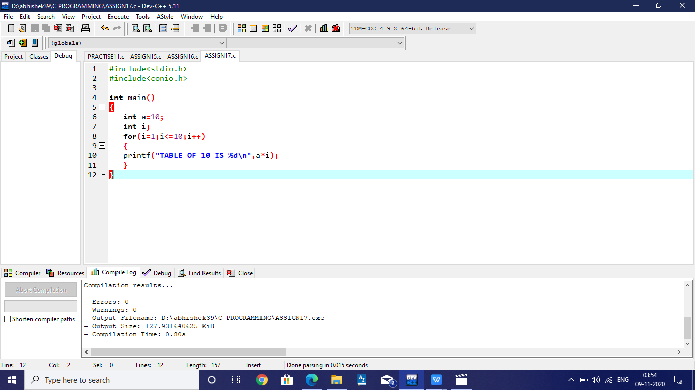

**18) Print the square of number between 1 and 10.**

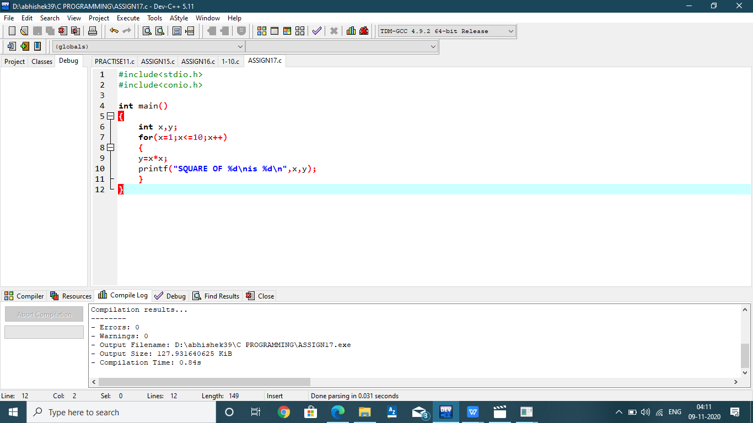

**19) Write a program to print the values between 1 and 30.**

**Skip valus as 1 5 9 10 15**

**Output : 23467811**

**20)Write a program to define marks of 5 subjects and print the average of marks.**

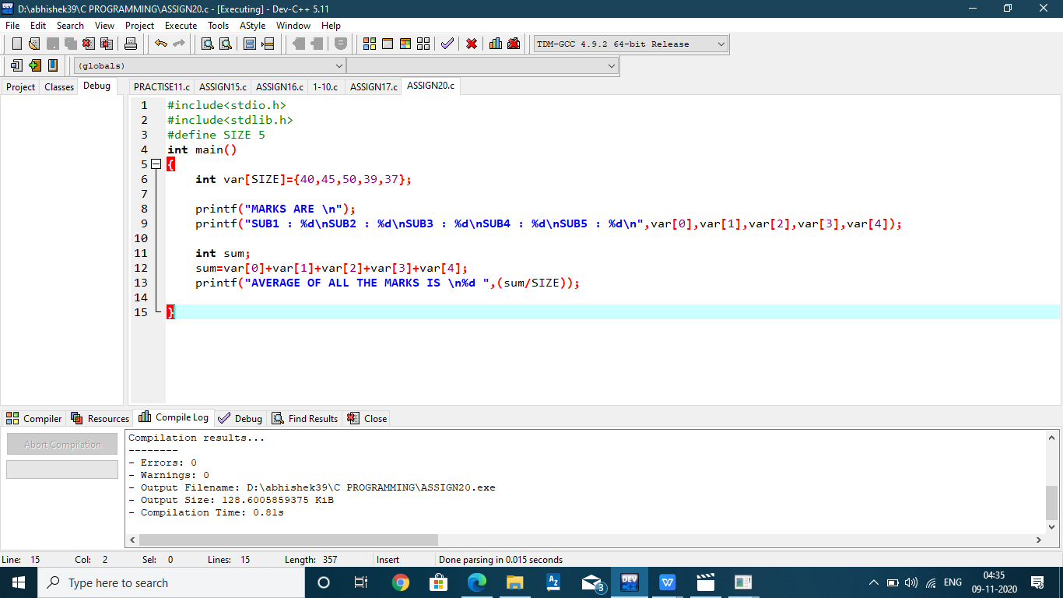

**21) Print the sum of numbers between 10 and 20.** 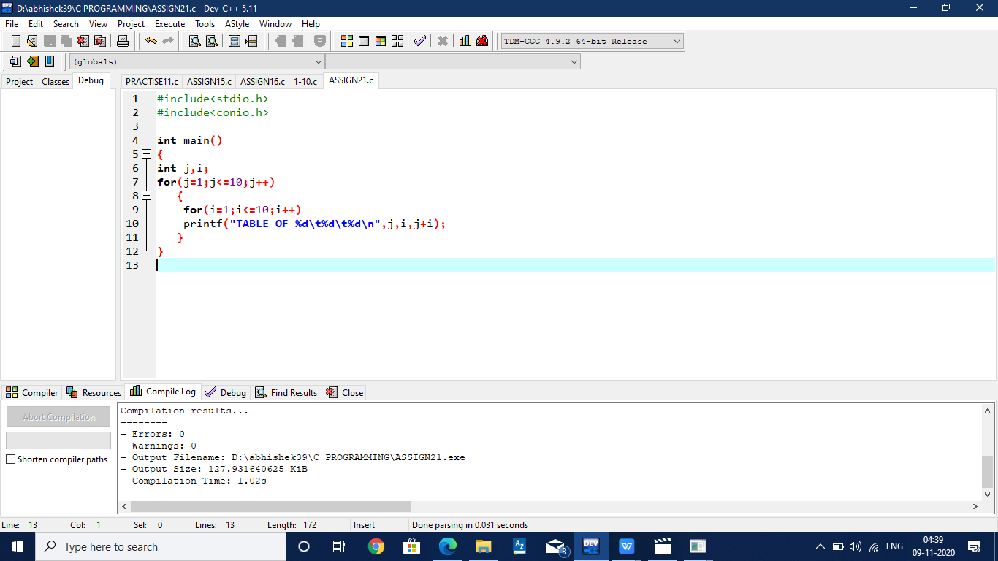

**22) Print the sum of only odd numbers between 1 and 10.** 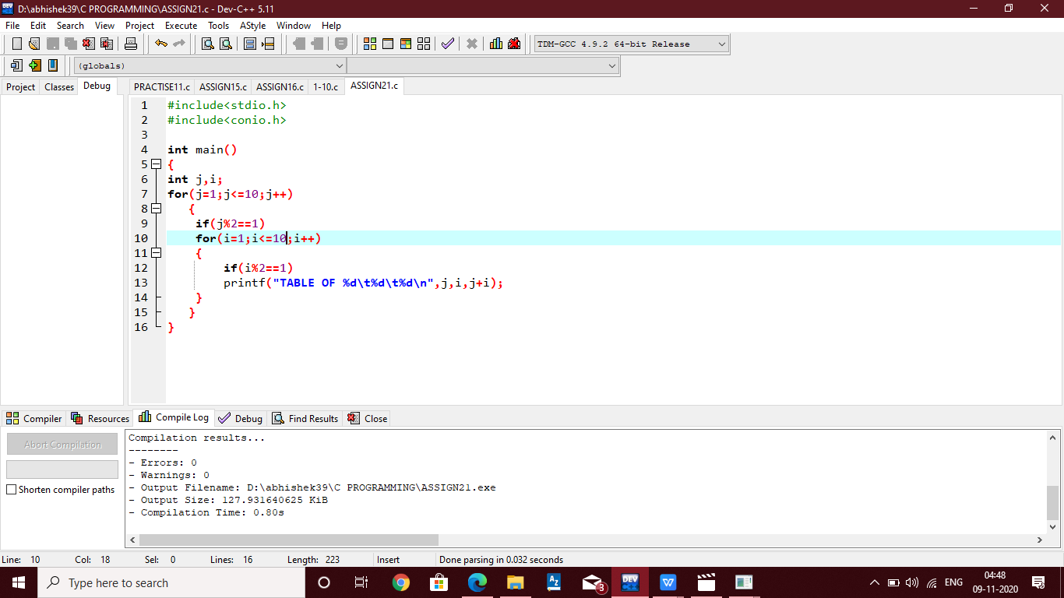

**23) Program to check a number is prime or not**

**24) Program to find Sum of digits**

**25) Program to find Largest of n numbers**

**26) Program to find Factorial of a number**

**27) Program to find Average of n numbers entered by user**

**28) Program to display fibonnacci series 0 1 1 2 3 5 8....**

**29) Program to swap 2 numbers**

1. **Write a program to define a float array of marks of 5 subjects of a studdent and calculate the average of marks and display.**